NOVEMBER 2023
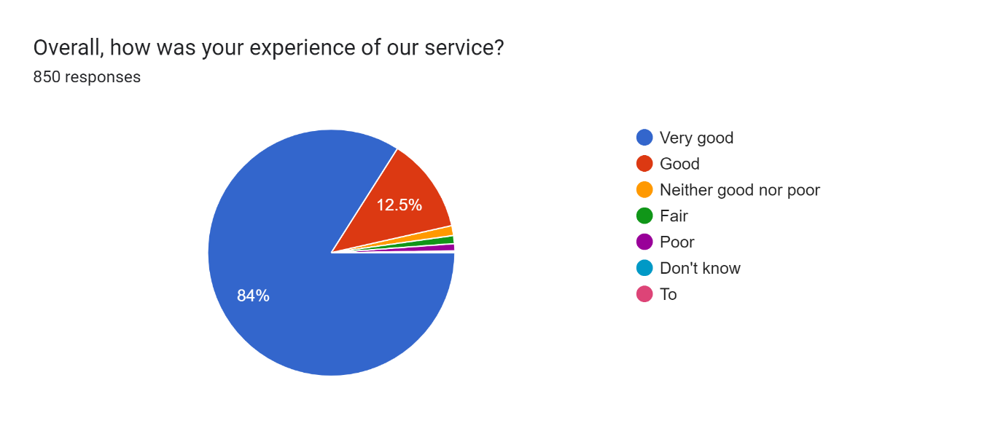
Surgery very clean nurse very good happy with my visit thank you

Our Doctor was as always very good and knowledgeable and able to give me great reassurance regarding my problem.

Although the practice is very busy, I was dealt with professionally and spoke with the doctor when they said he would.

Receptionist very polite and was pleased with the Doctors assessment and good explanation on my issue with which I went with

Got an appointment same day waiting time to see doctor was reasonable the Doctor was efficient and courteous.

